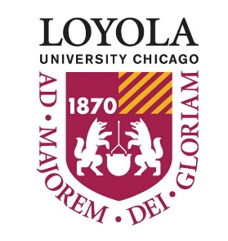
Polish Studies, European Studies, Department of History, Department of Modern Languages and Literatures Present
Adam Michnik on Poland Today
The Hardly Velvet Counterrevolution
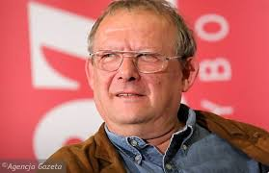
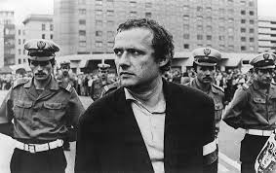

McCormick Lounge
April 16th, 11:30-1:30pm

Adam Michnik is a historian and has been editor-in-chief of the first independent Polish newspaper Gazeta Wyborcza since 1989. He was a co-founder of KOR (Committee for the Defense of Workers) in 1976 and was a prominent „Solidarity" activist during the 1980’s. He was detained many times during 1965-1980, for a total of six years in Polish prisons, for activities opposing the communist regime. Mr. Michnik was a member of the Round Table Talks in 1989 and a deputy in the first non-communist parliament 1989-1991. He is a laureate of many prizes and honorary titles among them Robert F. Kennedy Human Rights Award, the Erasmus Price, and the Adam Mickiewicz Award for his contribution to the development of French - German - Polish cooperation within the framework of the Weimar Triangle.
Pizza and refreshments will be provided

